How to Write a Scoping Review Protocol: Guidance and Template
Justine Lely,^{1a} Hailey C. Morris,^{1a} Noa Sasson,ª Nathan D. Camarillo,ª Alicia A. Livinski,^{b} Gisela Butera,^{b} Jordan Wickstrom^{a,c}
ªRehabilitation Medicine Department, Clinical Center, National Institutes of Health, Bethesda, MD, USA
^{b}NIH Library, Office of Research Services, National Institutes of Health, Bethesda, MD, USA
^{c}Sinai Rehabilitation Center, Sinai Hospital of Baltimore, Baltimore, MD, USA

TEMPLATE
TITLE
- Provide a clear title that represents the main objective(s) of your review, and include the words “scoping review protocol”

Beyond the Prompt: Approaches to Knowledge Boundary Detection in Large Language Models – A Scoping Review
AUTHOR AFFILIATIONS
- All authors: name, institutional affiliation
- Corresponding author: also include email address and physical mailing address

Brandon Colelough (corresponding Author), NIH, UMD, Fulbright
Davis Bartels, NIH
Dina Denmer-Fushman, NIH (likely for only final review)

ABSTRACT

Overarching Goal

Introduction
- Briefly overview the topic of interest
- Describe the rationale for the review
- Include an explicit objective statement

Overview of the Topic:
- The scoping review focuses on approaches to knowledge boundary detection in Large Language Models. Specifically, it investigates architectures, methods and datasets that help determine the boundaries of a Large Language Model’s embedded knowledge without relying on external sources or prompts.

Rationale for the Review:
- Preventing hallucinations in medical decision support systems is crucial for patient safety.
- Understanding Large Language Model knowledge boundaries can improve reliability of AI-driven medical information.
- A comprehensive review of current approaches to knowledge boundary detection in Large Language Models is needed.
Objective Statement:
- This scoping review aims to identify and map the current architectures, methodologies and datasets available that can assist in determining knowledge boundaries in Large Language Models, without the use of external information, to support more reliable AI systems, particularly in medical applications.

Methods and Analysis
- Describe methodology framework(s) to be used
- List key information regarding search strategy, including the names of search sources and limits to be applied
- List key information regarding screening and data extraction, including the piloting process and number of independent screeners and extractors
- Provide intended approach to data extraction and analysis

Methodology framework:
- This scoping review will follow the Joanna Briggs Institute (JBI) methodology for scoping reviews.
- The PRISMA Extension for Scoping Reviews (PRISMA-ScR) will be used as the reporting guideline.

Search strategy:
- Databases: Scopus, Web of Science, PubMed, IEEE Xplore, ACL Anthology, ACM Digital Library, Springer Link,
- Gray literature sources: OpenAI, Google AI, DeepMind publications, Microsoft, Amazon, Conference Workshops (e.g. Neurips, ACL, ICML etc), ?arXiv, Google Scholar, semantic scholar? (ask Dina)
- Limits: English language
- Search terms will include variations of :
("knowledge extraction" OR "knowledge retrieval") AND ("large language models" OR "LLMs" OR "generative models")
("knowledge representation" OR "formal representation") AND ("knowledge boundary" OR "boundary retrieval") AND ("large language models" OR "LLMs" OR "generative models")

Screening and data extraction:
- Two independent reviewers will screen titles/abstracts and full texts
- A pilot screening of 100 20 articles will be conducted to ensure consistency
- Data extraction will be performed by two independent reviewers using a standardized form
- Conflicts will be resolved through discussion or involvement of a third reviewer

Data analysis approach:
- Narrative synthesis of findings, focusing on knowledge extraction techniques, formal representation methods, and knowledge boundary detection approaches
- Results will be presented in tables and figures to map the current literature landscape
- Gaps in research will be identified to inform future studies in the field

For the presentation, I really liked this example from the JBI scoping review page:

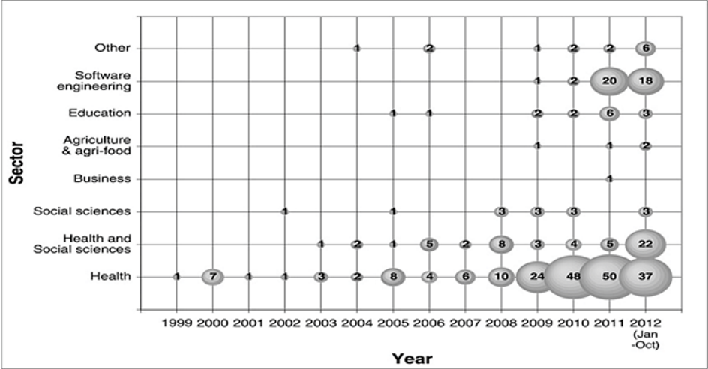

From <https://jbi-global-wiki.refined.site/space/MANUAL/355862811/10.2.9+Presentation+of+the+results>

Ethics and Dissemination
- State whether ethics approval will be necessary
No
- Describe intended dissemination of findings
Publication.
The scoping review findings will be disseminated through multiple channels:
- Publication in a peer-reviewed open-access journal
- Presentation at relevant academic conferences (AAAI?)
- Sharing results on social media platforms (LinkedIn, NIH platforms etc)
- Creating an infographic summarizing key findings
- Posting the full review on institutional repositories

Key Words or Phrases [Maximum: 5 words]
- List key words in alphabetical order

Neuro-Symbolic AI, Large Language Models, Decision Support Systems, Medical, Knowledge Graphs, Knowledge Extraction, Knowledge Boundary, Formal Representation, Hallucination, Hallucination Detection, Hallucination Mitigation, Meta-Cognition, AI in Healthcare, Generative Models
A few more than 5- haha

INTRODUCTION

Background and Rationale
- Provide rationale for why a scoping review should be done, including giving a brief topic overview, introducing new terms, and describing any gaps in the literature
- Explain why a scoping review is justified over other types of reviews
- Summarize and cite relevant literature and any existing reviews on the topic

Rationale for the Scoping Review:
Understanding the knowledge boundaries of Large Language Models is crucial for preventing hallucinations in Decision Support Systems especially in healthcare. Current literature lacks comprehensive exploration of architectures and datasets for detecting Large Language Models knowledge boundaries without external prompts, representing a significant research gap.

Justification for scoping review:
- Rapidly evolving field with diverse approaches and methodologies.
- Need to map existing literature and identify research gaps.
- Scoping review allows for broader inclusion criteria than systematic reviews.
- Helps inform future research directions in Large Language Model knowledge boundary detection.

In one sentence, I honestly just have not seen anything within the literature that does what we are suggesting we build, so I believe that an extensive literature review is required so we can prove that there is not any present architectures or datasets available to determine what a large language model knows WITHOUT using some sort of prompt engineering that ultimately provides external sources f information

Relevant literature:

Nothing that I have found so far, this paper from Davis (https://arxiv.org/abs/2402.11493) is similar to what we want to do but they end up just using a QA system with prompt engineering

Objective
- State primary and secondary research questions, including the population, intervention/ exposure, and outcomes of interest
- Use the words “scoping review” in the objective statement

This scoping review aims to identify and analyze existing architectures, methodologies and datasets for determining knowledge boundaries in Large Language Models without external information sources. We will explore methods for knowledge extraction, representation, and boundary retrieval in Large Language Models, focusing on applications in medical Decision Support Systems.

METHODS

[Opening Paragraph]
- List and cite the methodology the scoping review will follow
- List and cite the guideline(s) used for writing the scoping review protocol
- State you will use PRISMA Extension for Scoping Reviews as the reporting guideline for the scoping review manuscript

We’re using the scoping review methodology as described by the JBI manual:
https://jbi-global-wiki.refined.site/space/MANUAL/355862497/10.+Scoping+reviews

Eligibility Criteria
- List inclusion and exclusion criteria
- Provide rationale for all criteria
- Describe limitations/restrictions
- List plans for handling ambiguous information
- Ensure all team members have a shared interpretation of the criteria

Inclusion Criteria
- Focus on Knowledge Extraction:
  - The manuscript addresses methods or techniques for knowledge extraction from large language models without relying on external prompts.
  - This includes, but is not limited to, techniques that analyze embeddings, analyze tokens, extract vocabularies, or retrieve knowledge boundaries from Large Language Model.
- Knowledge Representation:
  - The study discusses formal representation of knowledge from Large Language Model s, which could involve knowledge graphs, symbolically queryable structures, or other methods for structuring extracted information.
- Knowledge Boundary Retrieval:
  - Research that explores the boundaries of knowledge within Large Language Model s, particularly in identifying or defining the limits of what Large Language Models know or how far the model’s embedded knowledge extends without relying on external prompts.

Exclusion Criteria (check for each criterion in order and report the topmost criteria satisfied)
Add the single identified exclusion reason string (the highlighted bullet point) to your annotations.
- The manuscript is not written in English.
  - not-in-english
- The manuscript is a literature review article.
  - review
- The manuscript is not a research article (e.g., editorial, commentary, perspective).
  - not-research
- Lack of Peer Review:
  - Exclude studies that have not undergone a peer-review process.
  - not-PR
- No Focus on Knowledge Extraction or Representation:
  - Exclude studies that do not focus on knowledge extraction or knowledge representation in LLMs or generative models.
  - not-KE/R
- Non-Generative Models:
  - Exclude studies that do not pertain to generative models (LLMs or similar.
  - not-GM

Information Sources and Search Strategy
- Specify who will develop search strategy
- List all sources to be searched and general search terms to be used
- For each source, include dates of search, limits/filters, general search terms
- List software that will be used for citation management
- Provide full search strategy for at least one database
- Mention if PRESS checklist will be/was used when creating search strategy

Search strategy will be developed collaboratively by Brandon Colelough and NIH Librarian Breck Turner.

Sources to be searched include databases (Scopus, Web of Science, PubMed, IEEE Xplore, ACL Anthology, ACM Digital Library, Springer Link) and gray literature (OpenAI, Google AI, DeepMind publications, Microsoft, Amazon, conference workshops, arXiv, Google Scholar, Semantic Scholar).

Search dates will cover beginning of time to present, limited to English language publications.

General search terms include "knowledge extraction," "large language models," "knowledge representation," and "knowledge boundary."• Covidence software will be used for citation management.

Full search strategy for Google Scholar:
- ("knowledge extraction" OR "knowledge retrieval") AND ("large language models" OR "LLMs" OR "generative models")
- ("knowledge representation" OR "formal representation") AND ("knowledge boundary" OR "boundary retrieval") AND ("large language models" OR "LLMs" OR "generative models")

The PRESS checklist will be used to evaluate the search strategy before implementation.

Study Selection/Screening
- State that eligibility criteria will be used for screening
- Describe title and abstract screening process, including pilot information, number of independent reviewers, how discrepancies will be resolved, how unclear information will be handled, and software to be used
- Describe full-text screening process, including pilot information, number of independent reviewers, how discrepancies will be resolved, how unclear information will be handled, and software to be used

Eligibility criteria is as per above

Title and abstract screening process:
- Pilot screening of 100 articles to ensure consistency between reviewers
- Two independent reviewers will screen titles and abstracts
- Discrepancies will be resolved through discussion or involvement of a third reviewer
- Unclear information will be flagged for full-text review
- Covidence software will be used for screening

Full-text screening process:
- Pilot full-text screening of 10 articles to refine criteria and ensure consistency
- Two independent reviewers will screen full texts
- Discrepancies will be resolved through discussion or involvement of a third reviewer
- Unclear information will be clarified by contacting study authors if necessary
- Covidence software will be used for full-text screening and tracking reasons for exclusion

Final Reviewer will be Dina (Independent?)

Data Charting/Collection/Extraction
- Describe data charting form development
- Specify data items to be collected
- Describe how the rules for data extraction will be stored
- Describe data extraction process, including pilot information, number of independent reviewers, how discrepancies will be resolved, how unclear or missing information will be treated, and software to be used
- Describe how friend studies will be handled

Data charting form development:
- A standardized data extraction form will be created in Covidence
- Form will be piloted on 10 studies by two independent reviewers and refined as needed

Data items to be collected:
- Study characteristics (e.g., authors, year, country)
- Large Language Model details (e.g., model type, size, training data)
- Knowledge extraction methods
- Knowledge representation techniques
- Knowledge boundary detection approaches
- Knowledge formalization approaches
- Any key architectures
- Any key methods
- Any key datasets
- Key findings and limitations

Rules for data extraction:
- Detailed extraction guidelines will be developed and stored in a shared document (likely through Notion)
- Regular team meetings will be held to discuss and clarify extraction rules

Data extraction process:
- Two independent reviewers will extract data from each included study (Brandon and Davis)
- Discrepancies will be resolved through discussion or involvement of a third reviewer (Dina)
- Unclear or missing information will be clarified by contacting study authors
- Covidence software will be used for data extraction and management

Handling of friend studies:
- Related studies (e.g., conference paper and full journal article) will be grouped
- Most comprehensive version will be used for data extraction
- Additional unique information from related publications will be included as needed

Synthesis and Presentation of Results
- Describe plan for cleaning data
- List any software to be used for data cleaning and analysis
- State that a PRISMA flow diagram will be used
- Describe how the data will be synthesized (e.g., with support from stakeholders) and presented in a meaningful way (e.g., tables, figures, diagrams)
- State intended plan for each data item

Data cleaning plan:
- Remove duplicate entries
- Standardize terminology and formatting
- Check for and resolve inconsistencies in extracted data

Software for data cleaning and analysis:
- Covidence
- Microsoft Excel for initial data cleaning and organization
- R or Python for advanced statistical analysis (if needed)

PRISMA flow diagram:
- A PRISMA flow diagram will be created to illustrate the study selection process

Data synthesis and presentation:
Something like this:

But I also do like the venn diagram approach:

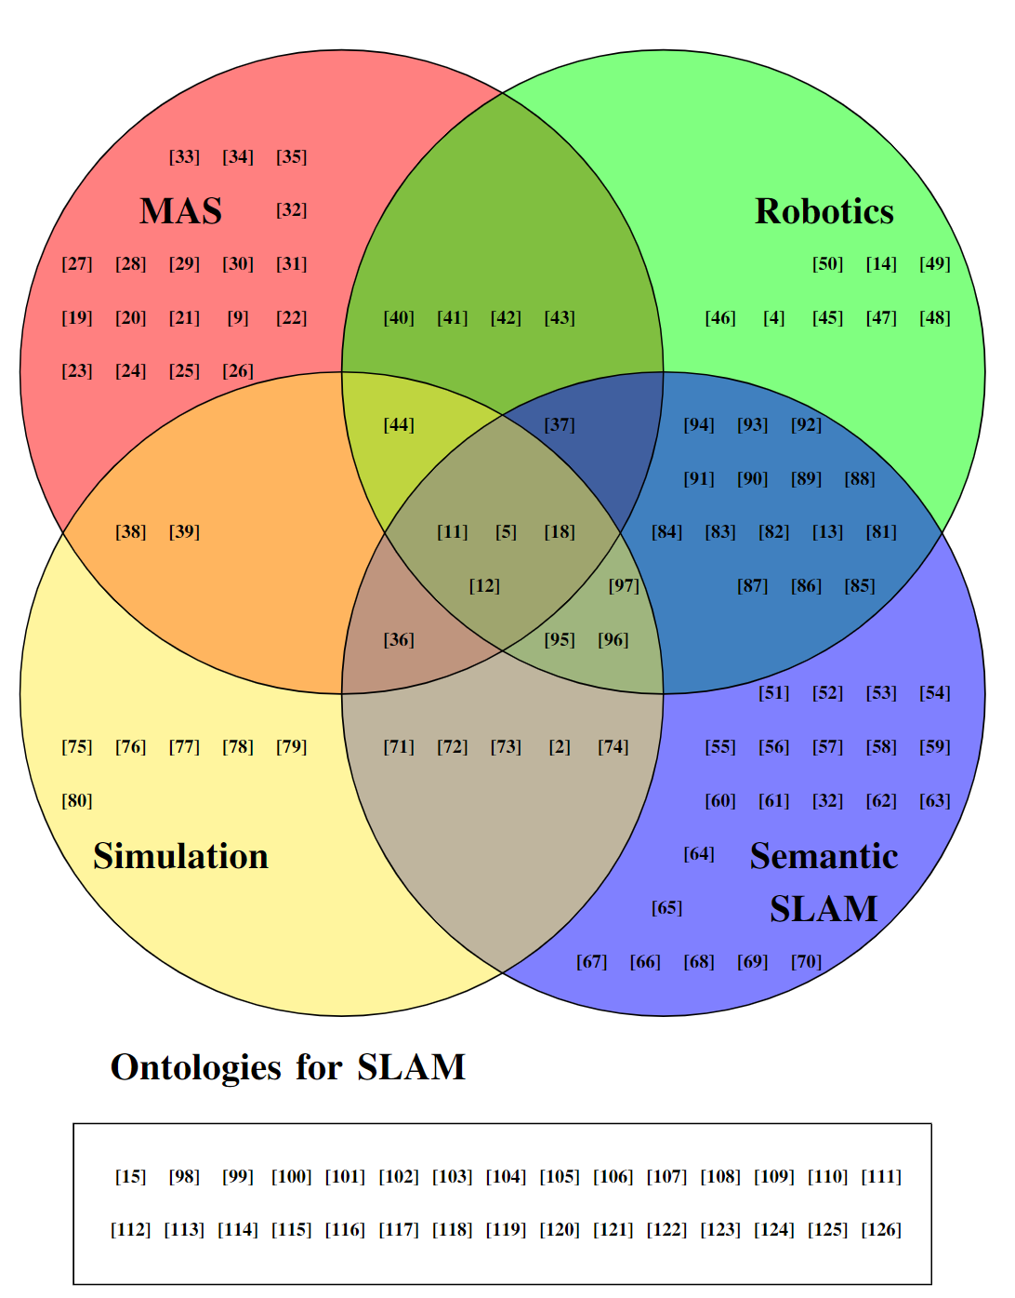

Intended plan for each data item:
- Study characteristics: Summarized in a table
- Large Language Model details: Presented in a comparative table
- Knowledge extraction methods: Categorized and presented in a diagram or flowchart
- Knowledge representation techniques: Summarized in a narrative format with illustrative examples
- Knowledge boundary detection approaches: Presented in a table with pros and cons
- Key findings and limitations: Synthesized narratively and highlighted in a summary box

Ethics and Dissemination
- State whether ethics approval is required
No
- Specify the roles of any collaborators or stakeholders
Nil
- Describe dissemination plans (e.g., conferences, journals)
As above (previously done in this document)
CONCLUSION
- Restate primary and secondary objectives
- Identify gap(s) the scoping review intends to fill
- Describe how the scoping review will advance the field

Restate primary and secondary objectives:
- This scoping review aims to identify and map the current architectures, methodologies and datasets available that can assist in determining knowledge boundaries in Large Language Model s, without the use of external information, to support more reliable AI systems, particularly in medical applications.
- Nil Secondary objectives.

Identify gap(s) the scoping review intends to fill

- Nil

Describe how the scoping review will advance the field

- Provide a systematic overview of existing methods for knowledge extraction and boundary detection in Large Language Model s, informing future research directions.
- Contribute to the development of more reliable AI-driven medical Decision Support Systems by mapping current approaches to hallucination prevention.
- Identify potential areas for innovation in neuro-symbolic AI and meta-cognitive oversight in medical chatbots.

SUPPORT/FUNDING
- State the names and roles of all funders and sponsoring institutions
NIH
- Provide all funding numbers and project titles
N/A
CONFLICTS OF INTEREST
- Disclose potential conflicts of interest, including supporting documentation (e.g., ICMJE)
Nil
ACKNOWLEDGEMENTS
- List names and describe roles of non-author contributors
Nil
REFERENCES
- Provide all references according to the formatting requirements of the submission source

?Nil?

